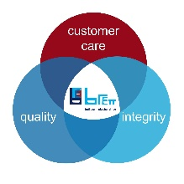
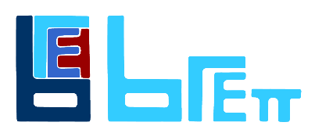

JOB TITLE: | People Officer
DEPARTMENT: | People team
COMPANY: | Robert Brett House (Group) Brett Trading
LOCATION: | Canterbury with flexibility to travel across the Brett sites as and when required
REPORTS TO: (Job Title of immediate supervisor) | Group Head of People
- ORGANISATION: (Show where this job fits in the organisation)

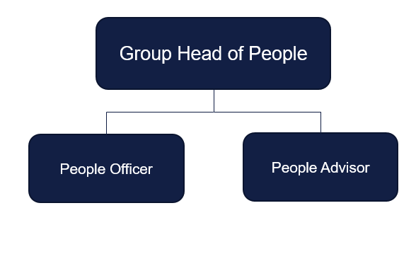

- RESOURCES:

Budget(s) Controlled/Influenced: None

Number of Direct/Indirect Subordinates: 0

Plant/Equipment Responsible For: NA

Key Internal/External Contacts:
Operational hiring managers, external recruitment agencies, government and social organisations

- PURPOSE OF THE JOB: (What is the main reason for this job to exist? How does it add value to the Company?)

The People Officer is a key role in setting out the foundations of support for the Group People team.

Working in a fast-paced environment, the role holder will support the operational activities of the full employee life cycle. The role plays a key part in all aspects of human resources, including employee relations, systems management, payroll, recruitment and the reporting of key people data. The role holder will act as the first point of contact for the business in providing advice with regards to onboarding, HR systems, policies and procedures.

This will enhance the employee experience and help the successful delivery of People projects.

The role will be based at the Brett Group head office in Canterbury reporting into the Group Head of People.

- MAIN RESPONSIBILITIES/TASKS: (What will the Job Holder actually do?)

Responsibilities/Tasks:

- Provide basic employment policy advice to line managers and employees on a range of HR matters, including:

- contract queries;

- policies and procedures;

- recruitment

- occupational health referrals.

- Support the effective onboarding of new starters at Canterbury head office and for senior hires across the Brett businesses and equally support a robust offboarding process.
- Be the main administrator for the Applicant Tracking System (Eploy) and for external job boards facilitating training where required across the business
- Support Group Head office recruitment
- Attend, and assist with events to promote Brett as a good employer
- Complete administrative tasks that include, but not limited to, maintenance of relevant HR systems and databases, approved supplier listing, generating letters/ documentation, taking notes/actions of meetings and the setting up of meetings/hearings.
- Draft guidance documents and policies where required.
- Co-ordinate L&D activities across a wide range of subjects both internally and externally, providing regular reports on progress making recommendations where appropriate. This will include the management of the apprenticeship portal.
- Act as the lead for HR support roles across the businesses and co-ordinate associated group activities. This will include providing a status report on projects and ensuring the correct instructions have been provided.
- Work with external providers to ensure seamless links between the organisation and the provision of services.
- Provide support to People Advisor and managers for case management.
- Work closely with the Head of People to set up people focussed forums ensuring a record of these is maintained and actions followed up in a timely manner.
- Produce a set of monthly reports for key people data.

- PERSON SPECIFCATION

Essential:

- Has worked in a HR related role with a minimum of 18 months experience or has worked in the industry as part of a work placement through studies.
- Educated to A level or above with a major in subjects such as business, HR or Industrial relations.
- Holds at least a level 3 CIPD status
- Has the ability to collate data and prepare reports
- Exceptional people skills.

Desirable

- Similar relevant work experience in minerals, construction or manufacturing industry
- Has been part of a HR IT system implementation project
- Has used Eploy or other applicant tracking system

