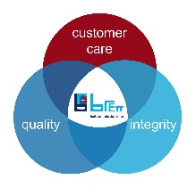
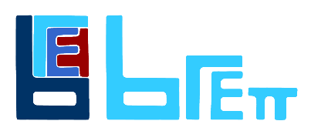

JOB TITLE: | HR Administrator
DEPARTMENT: | Senior Management
COMPANY: | Brett Landscaping and Building Products
LOCATION: | Barrow upon Soar, Leicestershire
REPORTS TO: (Job Title of immediate supervisor) | Managing Director
- ORGANISATION: (Show where this job fits in the organisation)

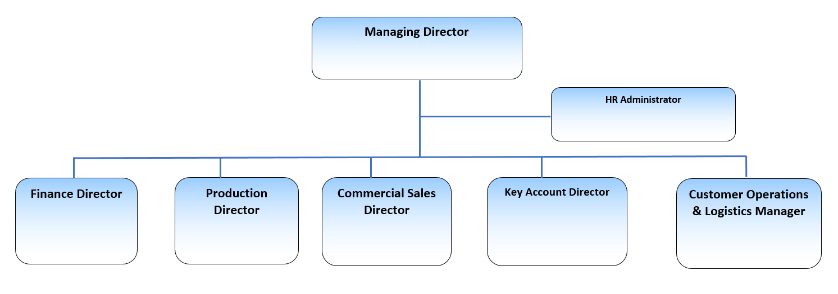

- RESOURCES:

Budget(s) Controlled/Influenced: NA

Number of Direct/Indirect Subordinates: None

Plant/Equipment Responsible For: None

Key Internal/External Contacts: Managers across the business and Group HR, Group IT and limited external HR specialists

- PURPOSE OF THE JOB: (What is the main reason for this job to exist? How does it add value to the Company?)

The HR Administrator is to support line managers across the business with HR issues which require support and complete essential monthly recording and reporting

Working in a fast-paced environment, the role holder will support the operational and commercial activities of the full employee life cycle. They will be the first point of contact for the business in providing advice with regards to the HR employee system, HR policies and procedures. This is a supportive role in all aspects of human resources, including employee relations, systems management, payroll, recruitment and the reporting of key people data.

The role will be based at the Brett Landscaping and Building Products head office in Barrow upon Soar, Leicestershire reporting to the Managing Director.

MAIN RESPONSBILITIES:
- Provide basic employment policy advice to line managers and employees on a range of HR matters, including:
- contract queries;
- policies and procedures;
- learning and development
- occupational health referrals
- occupational health monitoring

- Support the effective onboarding of new starters in Brett Landscaping and Building Products across its three operational sites of Barrow, Cliffe and Poole.

- Complete administrative tasks that include, but not limited to, maintenance of relevant HR systems and databases, generating letters/ documentation, taking notes/actions of meetings and the setting up of meetings/hearings.

- Draft guidance documents and policies where required.

- Co-ordinate L&D activities across a wide range of subjects both internally and externally, providing regular reports on progress making recommendations where appropriate.

- Build competency in HR systems to support with the management of employee records, provide adequate training and periodically update documents.

- Work with external providers to ensure seamless links between the organisation and the provision of services.

- Provide HR and administrative support to Senior Management team, Group People team and line managers for case management.

- Support people focussed forums ensuring a record of these is maintained and actions followed up in a timely manner.

- Produce a set of monthly reports from the HR system, as well as collating information from the business areas and anticipate any further information that may be required as a result of the data set.

- Assist the recruitment processes where required.

Person Specification

Qualifications & Experience:
- CIPD qualification - Level 3 minimum
- System Experience - 2 years minimum experience in working with HR systems like Day force, IFS, Sage, Workday etc
- Onboarding - experience in onboarding new starters
- Good Levels of Numeracy - competency to pull data from systems and produce HR reports
- Strong internal drive & enthusiasm
- Good basic knowledge and understanding of Employment Law
- Ability to multitask
- Excellent communication skills
- Ability to work autonomously
- Previous experience as an administrator in a busy department or has at least 3 years’ experience within a Human Resources
- Educated to A Level or equivalent

