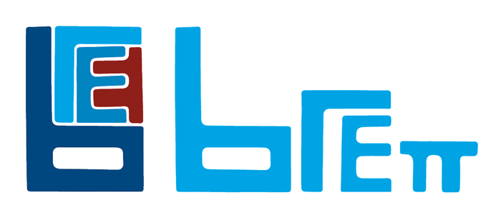
BRETT- JOB OUTLINE

JOB TITLE: | Site Operative
DEPARTMENT: | OPERATIONS
COMPANY: | BRETT AGGREGATES LTD
LOCATION: | Cliffe North Sea Terminal
REPORTS TO: (Job Title of immediate supervisor) | Chargehands
- PURPOSE OF THE JOB: (What is the main reason for this job to exist? How does it add value to Company?)

- To safely operate mobile and static plant for the production/handling/loading and sale of sand, gravel, and recycled material.
- To be flexible in the role allowing cover for other sites as directed.
- To safely operate plant to receive and despatch materials via road, water and rail.

- MAIN RESPONSIBILITIES/TASKS:
Responsibilities/Tasks & Performance Standards:

- Safely operate mobile and static plant, including routine daily/weekly/monthly checks as required in line with company procedures (QHEST).
- Maintain a good knowledge of safe and efficient working practices by attending organised training as directed.
- Carry out routine plant and site checks – In line with company policy and procedures (QHEST). Requirements.
- Assist with routine maintenance tasks, including but not limited to, belt tracking, scraper adjustment and roller and screen module changes arising from inspections to maintain sufficient production In line with company requirements.
- Report any accidents, incidents and defects or near misses in line with company procedures.
- Assist with housekeeping on site, including clearing spillages around the plant, and elsewhere on site.
- Work in line with company Safety, Health, Environmental and Quality policies and procedures.
- Carry out instructions as issued by line management.
- Carry out duties in a timely and professional manner.
- Work efficiently as part of a team offering support and assistance when necessary.
- Be flexible in working at other sites as required.

This job outline covers the main/most frequent responsibilities and duties included in the job. Other reasonable duties will be expected from time to time.

- TRAINING RESPONSIBILITIES FOR OTHER EMPLOYEES:

Assist the Manager/Supervisor/Chargehand with other employee training as necessary.
4. ANY OTHER RELEVANT INFORMATION:

- The role requires work to an agreed shift pattern, including night and weekend work.
- You may be required to work at other sites on occasion at short notice carrying out a similar function.

- BRETT QUALITIES:

Customer Care
Personal
Understand customer needs
Professional -To conduct business in a way which our customers will want to do business with us again

Integrity
We will do what we say
Value people, not position
Treat colleagues with respect
Communicates honestly, openly and on time
Respect safety, the environment and our neighbours

Quality
Attention to detail
People Deliver Quality
Superior service

6. KNOWLEDGE AND SKILLS:

Essential:

Mobile Plant Level 2 NVQ
Able to work under pressure
Able to work with others and as part of a team
Basic IT Skills
Basic understanding of quality requirements in the aggregate industry
Understanding of Health & Safety Legislation and Company procedures.
Understand customer needs
Flexibility to work at other local sites if required
UXO Level 1 Identification Qualification
Geotechnical Level 2 Qualificaiton

Desirable:

Able to work the weighbridge and produce speedy accurate tickets
Experience in working in a quarry, landfill, recycling or aggregates production role
Telephone skills
Effective Health & Safety practices

